SPANISH PUBLISHING
As everyone knows the publishing industry is the most important and noteworthy, according to the statistics of the European and indeed Spanish cultural industry. We are 42% of cultural GDP in Spain, which, in turn, is 3.2% of the GDP in Spain.
To present the book world in Spain, we will take into account both the industrial data as well as the most purely cultural, because both factors are inseparable.
I. SALES VOLUME FIGURES
As regards economic data as an industry and with figures from 2019, i.e., after nearly eight years of severe economic and financial downturn that was certainly not caused by the book world, yet it is suffering- as all public aid has gone to the financial world, the main perpetrator. Turnover for the domestic trade in Spain is situated in gross terms, including VAT at € 2,420.64 million; an increase of 2.4% compared to 2018. This figure does not include the sales of rights that will be taken into account later and can be seen in the annual outlook in the following table.
Table 1: Domestic trade turnover
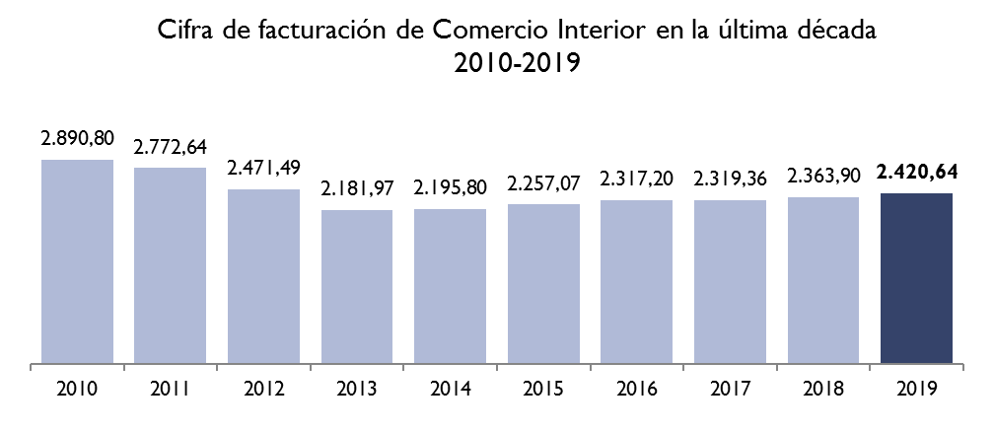
Cifra de Facturación de Comercio Interior en la última década

Source Domestic Book Trade 2019

Table 2 Turnover: Annual rate of change
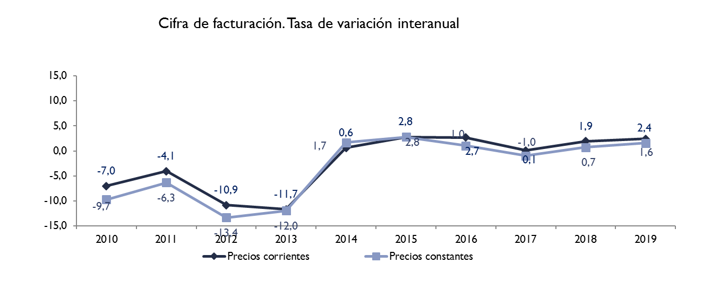

Source Domestic Book Trade 2019

This means that turnover at market prices including VAT has declined over the last ten years by 16.3% at current prices and by 23.6% at constant prices.

II. NET PUBLISHING PRICES, INCLUDING EXPORT
If we examine the net turnover exclusively in the publishing sector, no including VAT, at market prices this amounted €2,247.20 million in domestic trade (including €27.5 million for the sale of rights in Spain).
Nevertheless, an economic feature of the Spanish publishing industry, since it was set up as a distinct economic sector, is the strong propensity to export, and to fully understand Spanish publishing, this export activity, always given in net figures, must be taken into consideration, allowing it to be added to that of Domestic Trade and which is €354,79 million in goods and €71.00 million in services in 2019. I.e., €425.79 million.
The sum of Domestic Trade and Foreign Trade gives a net figure of €2,672.9 from Spain; to which it must be added another €100 million which our publishers export generally to America from printing centres in the Far East without going through Spanish Customs. The final net figure would be €2,772.9 million.
It should be noted that this export activity, let's say traditional, has combined with a strong presence abroad, there is an extensive network of subsidiaries whose decision-making centres are located in Barcelona and Madrid. There are currently 219 subsidiaries, belonging to 46 publishing houses that are technically (for being in the country of origin and in two other countries) multinationals and some of them more than 60 years old.
By region, 179 are in Latin America (82%), 24 in Europe (11%), 14 in the USA, 1 in Turkey and 1 in China. They are also leaders in their countries, in the subsector of textbooks, including literature for children and the young. Turnover exceeds €3,000 million
All this means that the book sector in Spain, including the graphics part, means practically 0.9 of the GDP
1. Employment
As regards employment, publishers directly hired 12,754 employees and a similar number of permanent indirect jobs together with booksellers, distributors and printing directly related to the world of books (9% of printing is books), totalling 100,000 jobs.
2. Competition
From the point of view of competition, the Spanish publishing industry is highly competitive with no publishing group being group dominant in all subsectors. Therefore, market abuse is not an issue for any company. If we calculate the Herfindahl-Hirschman index, used in the field of economic competition to indicate the degree of concentration of a given market, it gives us a value of 0.35 for the book market in Spain, well below the 1.00 which would indicate the highest degree of monopoly and close to the minimum of 0.33, indicating a strongly competitive structure in my opinion.
By turnover, by company size, the following table is very significant:
Table 3 Domestic market turnover (by size)
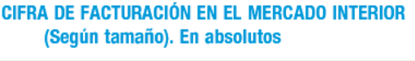
In millions of euros | 2015 | 2016 | 2017 | 2018 | 2019 | Variation 2019/2018
TOTAL | 2.257,07 | 2.317,20 | 2.319,36 | 2.363,90 | 2.420,64 | 2,4
Very large | 891,82 | 911,18 | 898,96 | 922,37 | 954,85 | 3,5
Large | 496,59 | 516,20 | 526,33 | 539,14 | 546,02 | 1,3
Medium | 584,87 | 600,43 | 578,03 | 580,06 | 592,09 | 2,1
Small | 283,79 | 289,39 | 316,05 | 322,33 | 327,68 | 1,7
Source Domestic Book Trade 2019
So from the economic point of view we find a modern publishing industry, at a later stage we will see the digital issue- competitive, strong and a highly globalized exporter.
The following shows a series of supplementary tables regarding the economic aspects of the publishing industry.

3. The average price of books by subject matter
Table 4 Average Price of books
 | Turnover  (millons €) | Copies sold  (thousands) | Average price
TOTAL | 2.295,08 | 162.219,17 | 14,15
Adult Fiction | 471,46 | 39.658 | 11,89
Novel | 427,29 | 35.887 | 11,91
Poetry, theatre | 7,17 | 605 | 11,85
Other literature | 37,00 | 3.166 | 11,68
Children´s and teenager´s Books | 305,43 | 28.779 | 10,61
Non-university textbook | 792,88 | 44.244 | 17,92
Non-fiction | 643,45 | 40.535 | 15,87
Technical, scientific and university | 104,34 | 4.509 | 23,14
Social Sciences and Humanities | 100,72 | 8.330 | 12,09
Law and economics | 114,22 | 3.037 | 37,60
Religion | 33,20 | 4.419 | 7,51
Practical books | 118,45 | 8.908 | 13,30
General interest | 134,72 | 9.711 | 13,87
Dictionaries and encyclopedias | 37,79 | 1.621 | 23,30
Comics | 62,43 | 8.142 | 7,67
Others | 19,43 | 861 | 22,57
Source Domestic Book Trade 2019

- The turnover figures by subject matter
Table 5

 | 2017 |  | 2018 |  | 2019 |  | Variation 2019/2018
 | Mills. € | % | Mills. € | % | Mills. € | % | Variation 2019/2018
TOTAL | 2.319,36 | 100 | 2.363,90 | 100 | 2.420,64 | 100,00 | 2,4
Ficción adultos | 451,70 | 19,5 | 488,19 | 20,7 | 496,78 | 20,5 | 1,8
Novela | 407,58 | 17,6 | 443,60 | 18,8 | 451,42 | 18,6 | 1,8
Classic | 38,38 | 1,7 | 42,97 | 1,8 | 46,37 | 1,9 | 7,9
Contemporary | 244,50 | 10,5 | 258,58 | 10,9 | 261,78 | 10,8 | 1,2
Police, spy. | 52,27 | 2,3 | 62,29 | 2,64 | 63,38 | 2,6 | 1,7
Romantic | 30,19 | 1,3 | 34,80 | 1,47 | 35,33 | 1,5 | 1,5
Science fiction, horror | 13,63 | 0,6 | 14,34 | 0,61 | 14,62 | 0,6 | 2,0
Erotic | 15,82 | 0,7 | 16,31 | 0,69 | 16,35 | 0,7 | 0,2
Humour | 7,63 | 0,3 | 8,61 | 0,36 | 8,06 | 0,3 | -6,3
Others | 5,17 | 0,2 | 5,70 | 0,24 | 5,54 | 0,2 | -2,8
Poetry, theatre | 7,00 | 0,3 | 7,18 | 0,30 | 7,28 | 0,3 | 1,4
Other literature | 37,12 | 1,6 | 37,41 | 1,58 | 38,09 | 1,6 | 1,8
Children´s and teenager´s Books | 286,17 | 12,3 | 303,33 | 12,8 | 312,18 | 12,9 | 2,9
Non-university textbook | 828,81 | 35,7 | 793,60 | 33,6 | 819,84 | 33,9 | 3,3
Early childhood education | 114,43 | 4,9 | 117,21 | 5,0 | 121,49 | 5,0 | 3,6
Primary education | 359,86 | 15,5 | 336,45 | 14,2 | 348,35 | 14,4 | 3,5
Secondary school | 190,42 | 8,2 | 175,68 | 7,4 | 181,26 | 7,5 | 3,2
Post-secondary school | 69,92 | 3,0 | 68,62 | 2,9 | 70,61 | 2,9 | 2,9
Vocational training | 17,79 | 0,8 | 18,01 | 0,8 | 18,15 | 0,7 | 0,8
Complem. Books and materials | 76,40 | 3,3 | 77,62 | 3,3 | 79,99 | 3,3 | 3,0
Non-fiction | 671,78 | 29,0 | 696,6 | 29,5 | 709,31 | 29,3 | 1,8
Technical, scientific and university | 107,46 | 4,6 | 111,5 | 4,7 | 112,37 | 4,6 | 0,8
Social Sciences and Humanities | 105,58 | 4,6 | 110,14 | 4,7 | 113,51 | 4,7 | 3,1
Law and economics | 124,80 | 5,4 | 127,62 | 5,4 | 128,57 | 5,3 | 0,7
Religion | 35,81 | 1,5 | 36,76 | 1,6 | 37,44 | 1,5 | 1,8
Practical books | 123,03 | 5,3 | 127,61 | 5,4 | 132,81 | 5,5 | 4,1
General interest | 135,26 | 5,8 | 142,07 | 6,0 | 143,74 | 5,9 | 1,2
Dictionaries and encyclopedias | 39,85 | 1,7 | 40,94 | 1,7 | 40,87 | 1,7 | -0,2
Comics | 62,76 | 2,7 | 62,67 | 2,7 | 62,99 | 2,6 | 0,5
Others | 18,13 | 0,8 | 19,48 | 0,8 | 19,53 | 0,8 | 0,2
Source Domestic Book Trade 2019

5. And the table by commercialisation sectors

Table 6 Total sales excluding VAT

By channels | Distributor | Direct | Total | Excluding VAT
Total (millions of euros)* | 1.354,11 | 960,00 | 2.314,10 | 2.221,54
Bookstores | 566,74 | 231,43 | 798,17 | 766,25
Bookstore chains | 249,04 | 187,88 | 436,92 | 419,44
Hypermarkets | 117,97 | 74,21 | 192,18 | 184,49
Newagents | 74,20 | 5,58 | 79,78 | 76,59
Companies | 186,81 | 142,78 | 329,59 | 316,41
Libraries | 3,76 | 7,12 | 10,88 | 10,45
Credit | 0,00 | 76,80 | 76,80 | 73,73
Book Clubs | 0,00 | 45,80 | 45,80 | 43,97
Internet | 0,94 | 22,71 | 23,65 | 22,70
Subscriptions | 0,00 | 67,95 | 67,95 | 65,23
Other | 154,65 | 97,73 | 252,39 | 242,29
Source Domestic Book Trade 2019

III. CULTURAL FEATURES
Here starts the analysis of cultural aspects and I must say in advance, as with the economic aspects, there are three major features.
- Its cultural pluralism or the elegant expression coined by a group of small publishers Madrid, bibliodiversity.
- Its pluralism, not only cultural but linguistic.
3. Openness to other cultures as revealed by the high number of translations.
Let's look at what cultural plurality refers to, analyzing it from the point of publication titles currently on sale.
So, if we follow the Study of the Domestic Book Trade for the year 2019, it tells us that there are 711,687 catalogued book titles, which would be the books on offer to the market and which can be located; as a benchmark since its inception in 1972 the ISBN Agency in Spain has granted numbers to and catalogued 2,609,888 books. We consider it of interest to ascertain their figures by year. (APPENDIX I).

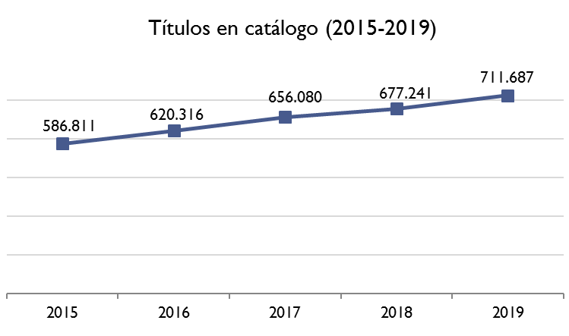
Table 7 Catalogued publication titles

Source Domestic Book Trade 2019

Catalogued books titles continue to grow; here are the last five years and annual growth rates
Table 8
2015 2016 2017 2018 2019
Interannual variation | 5,9 | 5,7 | 5,8 | 3,2 | 5,1
Variation compared to 2015 | 100,0 | 105,7 | 111,8 | 115,4 | 121,3

Source Domestic Book Trade 2019
This figure can also be seen by subject area where it is striking- showing the fragmentation of the Spanish educational system - with a staggering figure of 101,495 non-university textbooks, a spectacular 14.3% of all subjects, only surpassed by literature (21.3%).

Table 9
CATALOGUED BOOK TITLES (By subject)

 | 2017 |  | 2018 |  | 2019 |  | Variation 2019/2018
 | No. of titles | % | No. of titles | % | No. of titles | % | Variation 2019/2018
TOTAL | 656.080 | 100 | 677.242 | 100 | 711.687 | 100 | 5,1
Literature | 140.830 | 21,5 | 145.102 | 21,4 | 151.829 | 21,3 | 4,6
Novel | 102.674 | 15,6 | 105.726 | 15,6 | 110.247 | 15,5 | 4,3
Classic | 17.767 | 2,7 | 18.276 | 2,7 | 19.100 | 2,7 | 4,5
Contemporary | 58.581 | 8,9 | 60.276 | 8,9 | 63.148 | 8,9 | 4,8
Police, spy. | 9.107 | 1,4 | 9.543 | 1,4 | 9.738 | 1,4 | 2,0
Romantic | 4.926 | 0,8 | 5.023 | 0,7 | 4.994 | 0,7 | -0,6
Science fiction, horror | 6.837 | 1,0 | 7.058 | 1,0 | 7.408 | 1,0 | 4,9
Erotic | 680 | 0,1 | 709 | 0,1 | 735 | 0,1 | 3,8
Humour | 1.633 | 0,2 | 1.695 | 0,3 | 1.712 | 0,2 | 1,0
Others | 3.143 | 0,5 | 3.146 | 0,5 | 3.413 | 0,5 | 8,5
Poetry, theatre | 13.935 | 2,1 | 14.461 | 2,1 | 15.310 | 2,2 | 5,9
Other literature | 24.221 | 3,7 | 24.915 | 3,7 | 26.272 | 3,7 | 5,4
Children´s and teenager´s Books | 81.958 | 12,5 | 84.821 | 12,5 | 88.716 | 12,5 | 4,6
Non-university textbook | 93.453 | 14,2 | 97.225 | 14,4 | 101.495 | 14,3 | 4,4
Early chidhood education | 15.037 | 2,3 | 15.580 | 2,3 | 16.218 | 2,3 | 4,1
Primary education | 28.266 | 4,3 | 30.114 | 4,4 | 30.765 | 4,3 | 2,2
Secondary school | 19.841 | 3,0 | 20.407 | 3,0 | 21.646 | 3,0 | 6,1
Post-secondary school | 6.664 | 1,0 | 6.850 | 1,0 | 7.219 | 1,0 | 5,4
Vocational training | 5.799 | 0,9 | 5.907 | 0,9 | 6.169 | 0,9 | 4,4
Books and complementary materials | 17.846 | 2,7 | 18.367 | 2,7 | 19.476 | 2,7 | 6,0
Non-fiction | 312.308 | 47,6 | 321.779 | 47,5 | 339.289 | 47,7 | 5,4
Technical, scientific and university | 54.967 | 8,4 | 56.516 | 8,3 | 59.534 | 8,4 | 5,3
Social Sciences and Humanities | 88.360 | 13,5 | 91.292 | 13,5 | 95.777 | 13,5 | 4,9
Law and economics | 42.345 | 6,5 | 43.700 | 6,5 | 46.514 | 6,5 | 6,4
Religion | 30.836 | 4,7 | 31.698 | 4,7 | 33.500 | 4,7 | 5,7
Practical books | 40.783 | 6,2 | 41.992 | 6,2 | 44.386 | 6,2 | 5,7
General interest | 46.555 | 7,1 | 47.882 | 7,1 | 50.467 | 7,1 | 5,4
Dictionaries and encyclopedias | 8.463 | 1,3 | 8.700 | 1,3 | 9.110 | 1,3 | 4,7
Comics | 14.621 | 2,2 | 15.005 | 2,2 | 16.029 | 2,3 | 6,8
Others | 12.909 | 2,0 | 13.308 | 2,0 | 14.329 | 2,0 | 7,7

Source Domestic Book Trade 2019

Previously reference was made to the expression bibliodiversity, the term coined and defended by small publishers, in that regard, 50.8% of catalogued publication titles (about 361,499 publication titles) are held by small publishers; medium publishers account for 26.5% of the catalogue, with large and very large publishers the remaining 22.7%. Almost the reverse situation that occurs with turnover. In DILVE [Spanish Books in print Information Distributor], as of December 2019, there are 825,601 existing catalogued publication titles that do not exactly match the catalogued publication titles in the Domestic Book Trade Study, but for example in DILVE, fascicles have never been included, however they are included in the Domestic Trade Study.
I want to emphasize, as it reveals a significant offer effort, that books sold in electronic format in 2019 reached 182,108 publication titles with books for professionals and education showing a strong presence.

IV. EDITORIAL OFFER 2019
According to the study of the Domestic Book Trade for 2019, 82,347 books were published in Spain, 8.1% more than in 2018, and the ISBN Agency, eliminating author-publisher, recorded collectibles with a single ISBN and other technical adjustments, processed 77,327 (there is not necessarily a direct relationship between ISBN granted and its entry into the market. The Study of Domestic Book Trade measures the actual entry into the market and the ISBN are previously granted) and some do not enter the market as symbolic editions of doctoral theses
According to the Domestic Trade Study and in accordance with subject areas published they were distributed as follows.

Table 10
CATALOGUED BOOK TITLES (By subject)

TITLES | 2017 |  | 2018 |  | 2019 |  | Variation 2019/2018
TITLES | No. of titles | % | No. of titles | % | No. of titles | % | Variation 2019/2018
TOTAL | 60.124 | 100 | 56.966 | 100 | 60.737 | 100 | 6,6
Adult Fiction | 11.111 | 18,5 | 10.928 | 19,2 | 11.888 | 19,6 | 8,8
Novel | 8.836 | 14,7 | 8.648 | 15,2 | 9.565 | 15,7 | 10,6
Classic | 1.435 | 2,4 | 1.409 | 2,5 | 1.652 | 2,7 | 17,2
Contemporary | 4.301 | 7,2 | 4.255 | 7,5 | 4.567 | 7,5 | 7,3
Police, spy. | 859 | 1,4 | 836 | 1,5 | 952 | 1,6 | 13,9
Romantic | 1.408 | 2,3 | 1.362 | 2,4 | 1.502 | 2,5 | 10,3
Science fiction, horror | 398 | 0,7 | 386 | 0,7 | 446 | 0,7 | 15,5
Erotic | 45 | 0,1 | 40 | 0,1 | 43 | 0,1 | 7,5
Humour | 165 | 0,3 | 142 | 0,2 | 158 | 0,3 | 11,3
Other | 225 | 0,4 | 218 | 0,4 | 245 | 0,4 | 12,4
Poetry, theatre | 679 | 1,1 | 686 | 1,2 | 703 | 1,2 | 2,5
Other literature | 1.596 | 2,7 | 1.594 | 2,8 | 1.620 | 2,7 | 1,6
Children´s and teenager´s Books | 9.141 | 15,2 | 8.963 | 15,7 | 9.640 | 15,9 | 7,6
Non-university textbook | 13.166 | 21,9 | 11.884 | 20,9 | 12.742 | 21,0 | 7,2
Early childhood education | 2.013 | 3,3 | 1.935 | 3,4 | 2.004 | 3,3 | 3,6
Primary education | 4.834 | 8,0 | 4.098 | 7,2 | 4.540 | 7,5 | 10,8
Secondary school | 3.517 | 5,8 | 3.141 | 5,5 | 3.393 | 5,6 | 8,0
Post-secondary school | 648 | 1,1 | 621 | 1,1 | 660 | 1,1 | 6,3
Vocational training | 171 | 0,3 | 168 | 0,3 | 174 | 0,3 | 3,6
Books and complementary materials | 1.983 | 3,3 | 1.921 | 3,4 | 1.971 | 3,2 | 2,6
Non-fiction | 23.904 | 39,8 | 22.501 | 39,5 | 23.694 | 39,0 | 5,3
Technical, scientific and university | 3.638 | 6,1 | 3.366 | 5,9 | 3.551 | 5,8 | 5,5
Social sciences and humanities | 7.151 | 11,9 | 6.582 | 11,6 | 6.766 | 11,1 | 2,8
Law and economics | 3.058 | 5,1 | 3.005 | 5,3 | 3.207 | 5,3 | 6,7
Religion | 1.751 | 2,9 | 1.612 | 2,8 | 1.735 | 2,9 | 7,6
Practical books | 3.898 | 6,5 | 3.722 | 6,5 | 3.938 | 6,5 | 5,8
General interest | 4.115 | 6,8 | 3.927 | 6,9 | 4.201 | 6,9 | 7,0
Dictionaries and encyclopedias | 294 | 0,5 | 287 | 0,5 | 296 | 0,5 | 3,1
Comics | 1.875 | 3,1 | 1.784 | 3,1 | 1.825 | 3,0 | 2,3
Others | 927 | 1,5 | 906 | 1,6 | 948 | 1,6 | 4,6

Source Domestic Book Trade 2019

We again draw attention to the high number of textbooks 12,742, 21.0%, much higher than any other subgroup of subjects and that was previously explained. Literature provides 11,888 publication titles 19.6%) and a further 9,640 for children's and teenage literature (15.9%), social sciences and humanities 6,766 (11.1%).
However, it is the analysis of this year where we have wanted to dig deeper and we have asked the DILVE-ISBN system to give us all the publication titles excluded: author-editor, textbooks, fascicles, works in several volumes, non-commercial books and also recorded only once, publication titles repeated according to format or commercialisation method (soft-back, book club, newspapers promotions). In short, the authentic cultural offer, and the result is that in 2019, 63,465 publication titles appeared and the distribution of which with the THEMA subject category is as follows:
Table 11
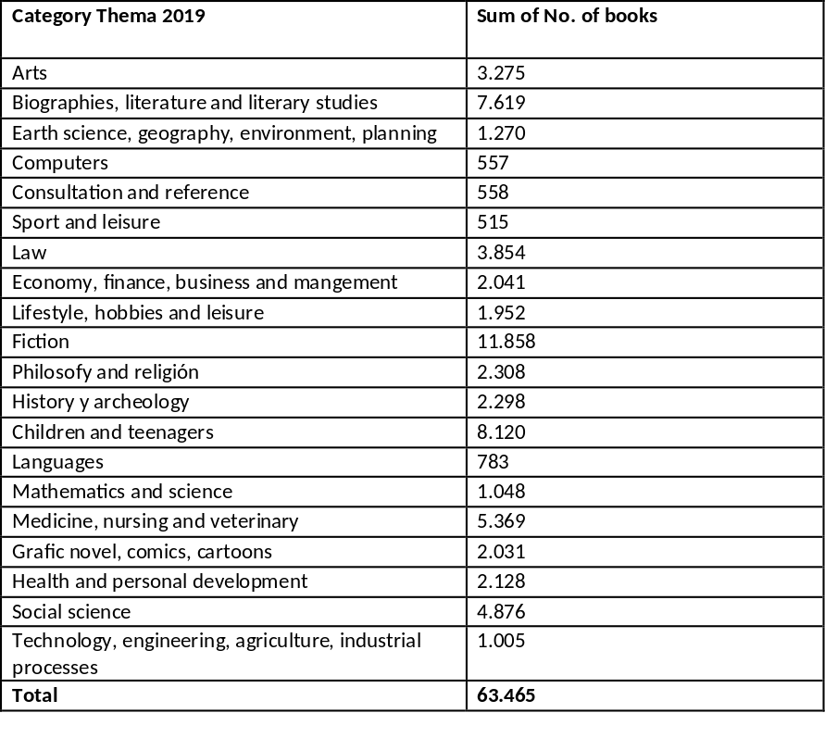
Source Own elaboration

As we see, removing the repeated publication titles according to commercialisation channels and other adjustments, there still remains a remarkable cultural offer (do not forget that each publication title is the equivalent of a prototype) and therefore we can say that the Spanish publishing offer is and remains a rich one, hence ensuring bibliodiversity.
It should be clear that simplification of publication titles being carried out, obviously, to try to determine the cold hard offer implies underestimating that the repetition of publication titles, for example, books and book clubs, paperbacks, etc., which repeat publication titles, is also a way to expand the offer, not so much from a cultural but from an economic perspective, to reach more readers.

V. LANGUAGE TRANSLATION
1. Foreign
Translations represent 17.0% of the total ISBNs granted and are distributed among the following languages:
Table 12
English | 6,524
French | 1,883
German | 625
Italian | 594
Source in-house

This signifies a remarkable cultural openness by the Spanish publishing houses comparable to the German one and much higher than the English-speaking environment. In short, the positive existence of a low level of ethnocentricity and narcissism.

2. Offer in co-official languages
By official languages and in terms of the publishing arena, the following is the distribution of official languages in Spain.
Table 13
Spanish | 65,990
Catalan | 6,676
Valencian | 818
Galician | 1,260
Basque | 1,116
Source In-house
With this figures it can be shown that in addition to cultural pluralism, Spanish publishing is also plurilinguistic, making an important effort to edit in the other co-official languages even though some of them are demographically restricted and make production costs more expensive, in my opinion without a strong Spanish edition it is very difficult to maintain publishing in these other languages.
Yet again we come up against the peculiarity of textbooks. Approximately 50% of turnover (this varies by Autonomous Region) in those languages comes from textbooks, which in turn are a significant component of the publication titles published.

VI DIGITAL FORMAT PUBLISHING
And last but not least, digital or technology issues, the Balsam of Fierabras that according to technology "experts" will save us (although they are only currently saving their bottom line and not ours).
Before examining the digital issue, I would like to point out that Spanish publishing through its organic representation, The Spanish Association of Publishers' Guilds, which I am honoured to preside, initiated in 2000 a process of technological modernization, opting for ONIX and for the standardization of subjects with Thema. The result is the establishment and organisation of the Spanish Books in print Information Distributor DILVE, which is a large metadata repository of catalogued publication titles belonging to, and I underline this ownership, the publishers, facilitating the commercial activities of booksellers, distributors, art work, librarians, and especially publishers themselves. Our commitment is that the information we generate is controlled by us and not outside the world of books.
Now for a closer look at the information.
Sales volume for books published electronically in 2019 reached €119.13 million, a 0.1% more than in 2018, representing 4.9% of total turnover in the Spanish publishing sector.
The number of titles published increased 12.3% compared to 2018, reaching 21,607. The total of titles in the catalogue is now of 182,108, a 1.8% more than in 2018.
The sale of copies sold in electronic format gives a figure of 12,73 million, a -1.1% of the total. The average price of the book is €9.36, 1.2% more than in 2018.
The following is a summary of the data obtained.
Table 14
Electronic Format Edition | 2017 | 2018 | 2019 | Variation
Titles published in electronic format | 27.138 | 19.236 | 21.607 | 12,3%
Titles marketed in electronic format | 178.154 | 178.908 | 182.108 | 1,8%
Turnover from book sales in electronic format (thousands of euros) | 119.100 | 118.984 | 119.130 | 0,1%
Copies sold in digital format (millions of copies) | 12,8 | 12,8 | 12,7 | -1,1%
Average Price of the book in electronic format (euros) | 9,3 | 9,3 | 9,4 | 1,2%
Source Domestic Book Trade 2019

Most of the publication titles were published in 2019 (89.2%) were published both electronically and on paper and only 10.8% were published only in electronic form. There was a increase from 19.6% in 2018 to 24.3% in 2019 of digital editions of books published offering additional content (links, comments, videos, illustrations ...) not available in the paper version.

Table 15 Turnover of electronic books by subject matter
 | 2017 |  | 2018 |  | 2019
Invoicing Electronic format (x 1.000) | 119.100 | 100,0% | 118.984 | 100,0% | 119.130 | 100,0%
Literature | 23.653 | 19,9% | 23.886 | 20,1% | 23.998 | 20,1%
Novel | 22.364 | 18,8% | 22.647 | 19,0% | 22.838 | 19,2%
Poetry, theatre | 74 | 0,1% | 90 | 0,1% | 80 | 0,1%
Other literature | 1.215 | 1,0% | 1.150 | 1,0% | 1.080 | 0,9%
Children´s teenage literature | 5.796 | 4,9% | 5.700 | 4,8% | 5.826 | 4,9%
Non-university textbook | 26.730 | 22,4% | 25.730 | 21,6% | 26.066 | 21,9%
Non-fiction | 62.168 | 52,2% | 62.710 | 52,7% | 62.852 | 52,8%
Comics | 257 | 0,2% | 280 | 0,2% | 289 | 0,2%
Others | 497 | 0,4% | 680 | 0,6% | 100 | 0,1%
Source Domestic Book Trade 2019

77.4% of sales of books published in electronic format occur mainly through specific marketing platforms, 45.5% through generic platforms and 24.2% through Amazon, and through specific digital distribution platforms created by the publishers (28.5%). 18.3% of the digital turnover comes from direct sales from publisher's web.

Table 16 Distribution / sale channels for electronic books

 | 2017 |  | 2018 |  | 2019
Turnover Electronic format (x 1.000) | 119.100 | 100,0% | 118.984 | 100,0% | 119.130 | 100,0%
Direct sale from the publisher´s website | 17.879 | 15,0% | 21.357 | 17,9% | 21.824 | 18,3%
Sale through specific digital distribution platforms (e-distributors) | 94.769 | 79,6% | 91.358 | 76,8% | 92.180 | 77,4%
Platform created by the publisher | 32.918 | 27,6% | 34.027 | 28,6% | 33.981 | 28,5%
Joint platform with other publishers | 5.786 | 4,9% | 4.018 | 3,4% | 4.007 | 3,4%
Generic trading platform and other platforms | 56.065 | 47,1% | 53.314 | 44,8% | 54.192 | 45,5%
Amazon | 26.637 | 22,4% | 27.145 | 22,8% | 28.825 | 24,2%
Casa del libro | 8.824 | 7,4% | 8.348 | 7,0% | 8.421 | 7,1%
Fnac | 1.400 | 1,2% | 1.211 | 1,0% | 1.221 | 1,0%
Google Play | 3.587 | 3,0% | 2.626 | 2,2% | 2.689 | 2,3%
App Store | 6.392 | 5,4% | 6.822 | 5,7% | 5.446 | 4,6%
Labranda | 1.133 | 1,0% | 1.007 | 0,8% | 1.167 | 1,0%
Other platforms | 8.092 | 6,8% | 6.155 | 5,2% | 6.423 | 5,4%
Sales through bookstores | 930 | 0,8% | 864 | 0,7% | 857 | 0,7%
Reading centres / Libraries* | - | - | 622 | 0,5% | 525 | 0,4%
Other channels | 5.522 | 4,6% | 4.781 | 4,0% | 3.744 | 3,1%
Source Domestic Book Trade 2019

The distribution of invoicing by language in electronic format can be seen in the following table, 92.2% of digital revenues are electronic books published in Spanish and 7.7% in Catalan.
Table 17
Language | 2017 |  | 2018 |  | 2019
Turnover Electronic format (x 1.000) | 119.100 | 100,0% | 118.984 | 100,0% | 119.130 | 100,0%
Spanish and others | 108.049 | 92,2% | 107.938 | 90,7% | 108.014 | 90,7%
Catalan | 8.989 | 7,7% | 8.937 | 7,5% | 9.004 | 7,6%
Basque | 1.301 | 1,1% | 1.321 | 1,1% | 1.341 | 1,1%
Galician | 762 | 0,6% | 789 | 0,7% | 771 | 0,6%
Source Domestic Book Trade 2019
VII PUBLISHING ON OTHER MEDIA
Of the total of 722 publishing companies, 375 published in 2019 in media other than paper.
Table 18 Publishers that publish on other media
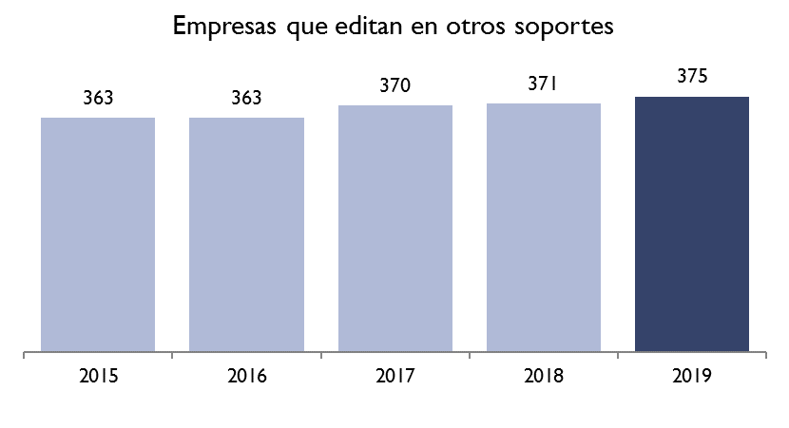

Source Domestic Book Trade 2019

62.1% of the market corresponded to online/digital books, the rest corresponded to "Others" with 28.6% of the total, fascicles/Monographic publications (4.1%), educational or didactic programmes (4.0%) and the rest of the supports did not add up to 2% of turnover.
Table 19
TURNOVER ON OTHER MEDIA
(by media type)
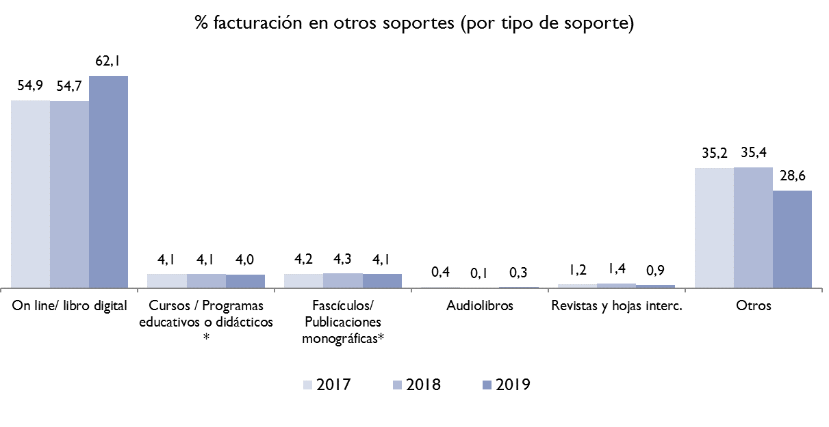

Source Domestic Book Trade 2019

ANNEX I
ISBN GRANTED PER YEAR
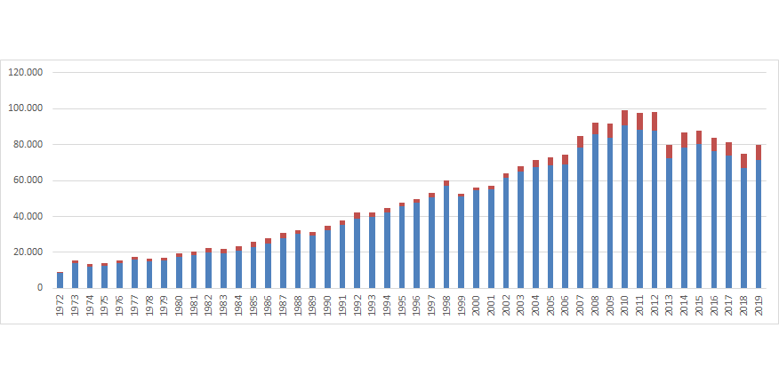Source ISBN Agency

